David Pyle

041110777@my.central.edu.au

Assignment 3

UI .NET

Contents

1 Introduction 3

2 Prototype Tool 3

3 Client Requirements 3

3.1 Login 3

3.2 Customer Details 3

3.3 Invoice Details 3

3.4 Search 3

3.5 Edit 3

3.6 Change Interface Background Image 3

3.7 Interface 3

4 UI Design and Components 4

4.1 Overview 4

4.2 Login Form 4

4.2.1 Login Error 4

4.3 Customer Details 5

4.3.1 View Customer Details 5

4.3.2 Add a Customer 6

4.3.3 Edit Customer 8

4.3.4 Delete Customer 8

4.4 Invoice Details 9

4.4.1 View Invoice Details 9

4.4.2 Add Invoice 10

4.4.3 Edit Invoice 11

4.4.4 Delete Invoice Item 12

4.4.5 Delete Invoice 12

4.5 Search 13

4.5.1 Search by Customer Name 13

4.5.2 Search by Invoice Number 13

4.6 Interface 15

4.6.1 Change Interface Background Image 15

5 Testing 16

5.1 Login Test 16

5.2 View Customer Test 16

5.3 View Invoices Test 16

5.4 Add Customer Test 17

5.5 Add Invoice Test 18

5.6 Edit Invoice Test 18

5.7 Delete Invoice Test 19

5.8 Edit Customer Test 20

5.9 Delete Customer Test 20

5.10 Search Customers Test 21

5.11 Search Invoices Test 21

5.12 Change Interface Background Test 22

6 Annex A – UI Component Details 23

6.1 Login Form UI Components 23

6.2 Main Form UI Components 23

6.3 Add Customer, Edit Customer UI Components 24

6.4 Add Invoice, Edit Invoice UI Components 25

# Introduction

This report will describe the design for the ABC Invoice application. The purpose of the application is to help manage customer and invoice details.

The report documents the client requirements, provides descriptions of the user interface (UI) components used, screenshots of the proposed design and a test table that can be used for acceptance testing.

# Prototype Tool

The UI was designed using Visual Studio 2013 and the application is written in C#.

# Client Requirements

The client requirements for the ABC Invoice application are listed below in sections 3.1 to 3.7.

## Login

**Requirement**: The system must provide a login screen. Access to the main application is only granted once the user has been authenticated. If authentication fails an error message is displayed.

## Customer Details

**Requirement:** The system must record the following customer details:

* Customer Number
* Customer Name
* Address
* Invoice number
* Contact number

## Invoice Details

**Requirement**: The system must record the following invoice details:

* Invoice Number
* Customer Number
* Description
* Costs
* Payment Date

## Search

**Requirement**: The system must be able to search for records by:

* Invoice Number
* Customer Name

## Edit

**Requirement**: The system must be able to edit customer and invoice details.

## Change Interface Background Image

**Requirement**: The system must provide the facility to change the background image of the application’s interface.

## Interface

**Requirement**: In addition, the interface design to be simple, sleek and consistent.

# UI Design and Components

## Overview

The user interface (UI) design is based around the customer entity. The customer is central to how a user interacts with the application. From the main view the user can view, add, edit, delete and search customer records as well as view, add, edit and delete invoices for a customer.

This design approach avoids the possibility of orphan invoice records, i.e. an invoice that doesn’t belong to a customer. The design also simplifies how a user can view and interact with the customer and invoice data. By only having a single main view based around the customer it avoids switching between different ways of viewing the data. i.e. searching for customers or invoices can all be done from the main form, there is no need to ‘switch’ between a customer view or invoice view.

For this stage of development the ABC Invoice application supports the creation of 20 customers and each customer can have up to 10 invoices. Invoices can contain an unlimited number of items.

## Login Form

This is the first form displayed when the application opens.

Section 6.1 in Annex A describes each UI component for the Login form.

**Requirements addressed**: 3.1, 3.7

**Input:** username, password

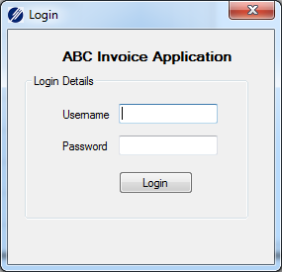

Figure 4.1 Login Screen

### Login Error

If authentication fails an error message is displayed.

**Input:** username, password

**Output:** error message

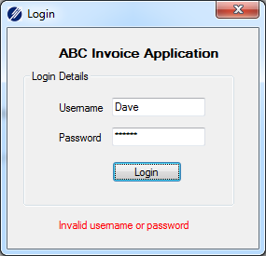

Figure 3.2 Login Screen error

## Customer Details

The ability to view, add, edit and delete customer records.

**Requirements addressed:** 3.2, 3.4, 3.5, 3.7

Customer records are stored in an array of customer objects. When adding or editing customer records the same customer form is used along with all of its UI components (buttons, labels etc.). In the case of adding a new record all fields are blank, but, if editing, the fields are populated with the selected customer details.

Section 6.2 and 6.3 in Annex A describes each UI component for the main form and customer form.

### View Customer Details

**Output**: customer number, company, first name, last name, street address, suburb, state, post code, contact number and any associated invoices.

The main form in figure 4.3.1 shows how the customer details are displayed (highlighted by red box).

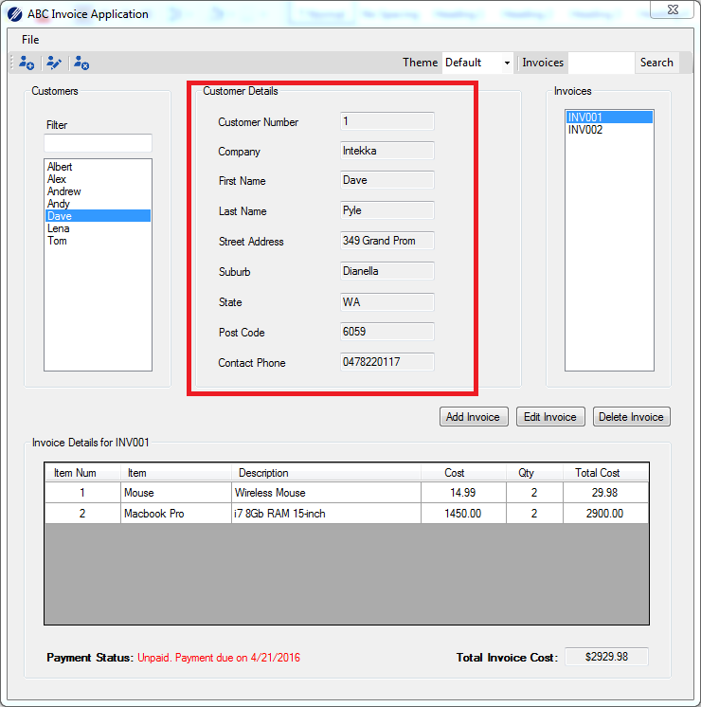

Figure 4.3.1 Customer Details

### Add a Customer

**Input:** customer number*, company, first name, last name, street address, suburb, state, post code, contact number

*Customer number will be auto-generated by the application

The add customer form can be accessed by keyboard shortcut (Ctrl-N), File menu ‘Add Customer’ or the ‘Add Customer’ button.

All fields are required for a customer to be created.

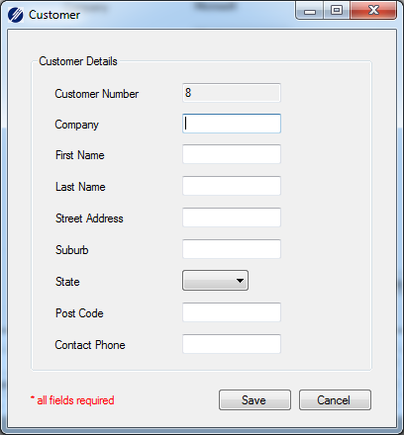

Figure 4.3.2 Add Customer

#### Add a Customer Error

**Input:** customer number*, company, first name, last name, street address, suburb, state, post code, contact number

*Customer number will be auto-generated by the application

**Output:** error message

If the user attempts to save the record without completing all fields an error message will be displayed.



Figure 4.3.2.1 Add Customer Error

### Edit Customer

**Input**: customer number*, company, first name, last name, street address, suburb, state, post code, contact number

*Customer number will be read only

The edit customer form can be accessed by keyboard shortcut (Ctrl-E), File menu ‘Edit Customer’ or the ‘Edit Customer’ button.

All fields are required for a customer when saving the changes.

When editing a customer, the same customer form is used as in figures 4.3.2 and 4.3.2.1.

### Delete Customer

**Input:** customer name

**Output:** confirmation dialog

Deleting a customer can be done by keyboard shortcut (Ctrl-D), File menu ‘Delete Customer’ or the Delete Customer button.

A confirmation dialog is displayed when deleting a customer. If ‘Yes’ is selected the customer is removed from the customer array and any invoices associated with the customer are no longer displayed/available.

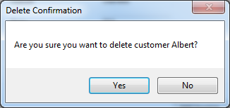

Figure 4.5 Delete Customer Confirmation Dialog

## Invoice Details

The ability to view, add, edit and delete invoice records.

**Requirements addressed:** 3.3, 3.4, 3.5, 3.7

Invoice records are stored in an array of invoice objects. The invoice array is related to a customer object. When adding, or editing invoice records the same invoice form is used along with all of its UI components. In the case of adding a new record all fields are blank but if editing, the fields are populated with the selected invoice details.

Invoice items are stored as a list of item objects. The items list is related to an invoice object.

Section 6.2 and 6.4 in Annex A describes each UI component for the main form and invoice form.

### View Invoice Details

**Output:** invoice number, customer details, payment due date, payment status, invoice total cost and for each item on the invoice – item number, item name, item description, item cost, quantity and total item cost

The main form in figure 4.6.1 shows how the invoice details are displayed (highlighted by red box).

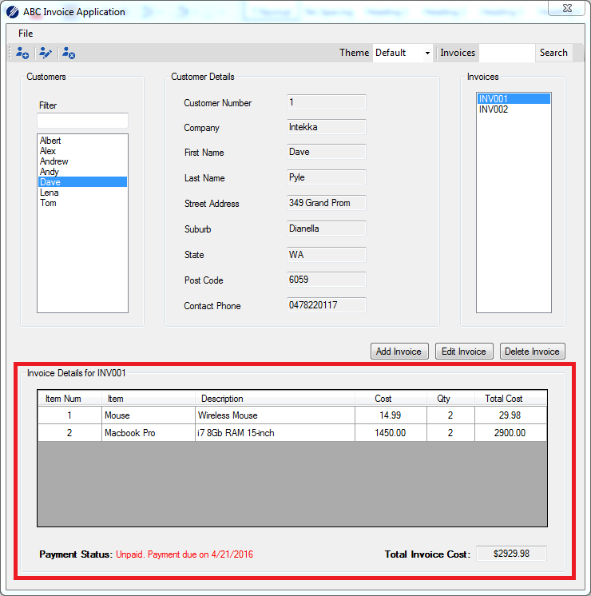

Figure 4.6.1 Invoice Details

### Add Invoice

**Input:** invoice number, payment due date, payment status and at least one item by selecting item name and quantity.

The item’s number, description, cost and total item cost will be filled in automatically by the system.

*Invoice number will be auto-generated by the system

The add invoice form can be accessed by the Add Invoice button. It is not possible to save an invoice (Save button is disabled) unless at least one item has been added.

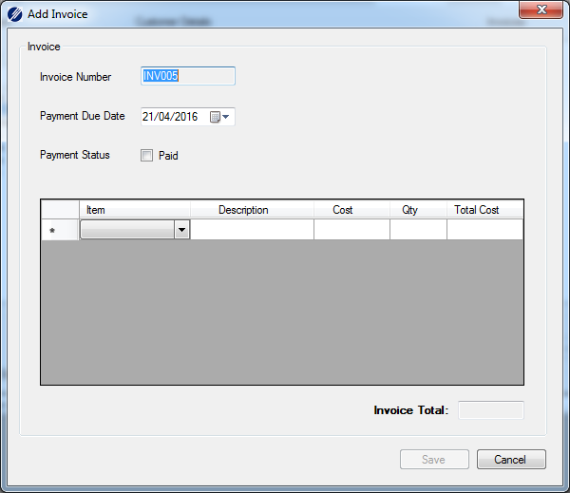

Figure 4.6.2 Add Invoice

### Edit Invoice

**Input**: payment due date, payment status, item name, quantity

When editing an invoice, items can be added by selecting an item name from the drop-down list. Once an item is added the item number, description, cost, quantity (initially set to 1) and total cost are automatically filled in. The user can then edit the quantity for the item.

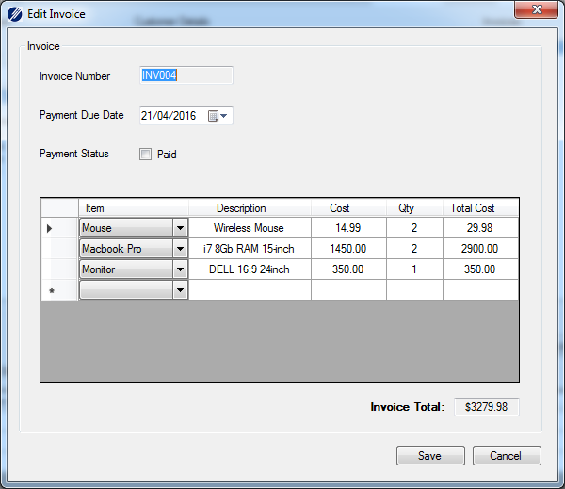

Figure 4.6.3 Edit Invoice

### Delete Invoice Item

The ability to delete an item from an invoice.

Item rows can be deleted by selected the row and pressing the delete key. If all items are deleted the ‘Save’ button is disabled.

### Delete Invoice

**Input:** invoice number

**Output:** confirmation dialog

Deleting an invoice is done by selecting an invoice number from the list of invoices and then using the ‘Delete Invoice’ button.

A confirmation dialog is displayed when deleting an invoice. If ‘Yes’ is selected the invoice is removed from the customer’s invoice array.

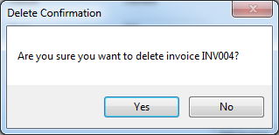

Figure 4.6.5 Delete Invoice Confirmation Dialog

.

## Search

The ability to search customer records by customer name and to search for an invoice by invoice number.

**Requirements addressed:** 3.4, 3.7

Every customer name is displayed in the customer list and can be searched by using the ‘Filter’ field. Invoice numbers related to a customer are displayed in the invoice list box and can be searched by using the ‘Invoices’ search field and ‘Search’ button.

### Search by Customer Name

The ability to search for a customer record by customer name

**Input**: customer name

Figure 4.7.1 shows how customer records can be searched for by entering text into the Filter field. As text is entered, the customer list is filtered to only those customer names that match the filter text.

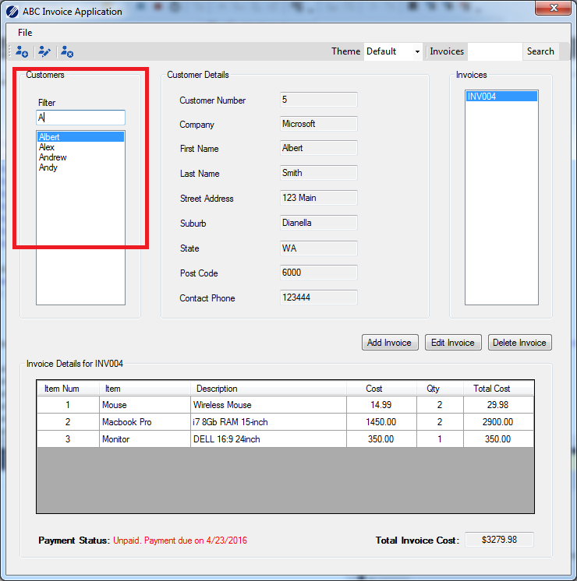

Figure 4.7.1 Customer Name Search

### Search by Invoice Number

The ability to search for an invoice by invoice number

**Input**: invoice number

Figure 4.7.2 shows how invoice records can be searched by entering text into the ‘Invoices’ search field and pressing the ‘Search’ button. As text is entered, a pop-up showing a list of invoice numbers that match the search text is displayed just below the search field. To retrieve the details for the invoice the ‘Search’ button is clicked.

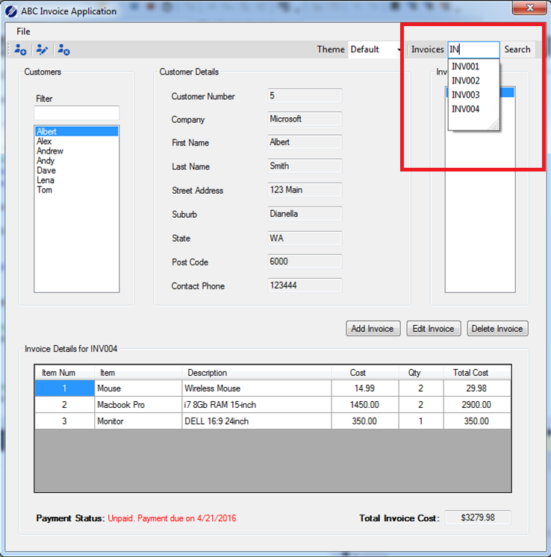

Figure 4.7.2 Invoice Number Search

#### Search by Invoice Number Message Dialog

**Input**: invoice number

**Output:** search results message dialog

If an invoice number search is performed and no records are found a message is displayed to the user.

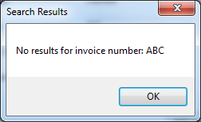

Figure 4.7.2.1 No Results Message Dialog

## Interface

The UI has been designed using a consistent approach to layout, style and colours for the various forms that make up the application. The user also has the ability to select between three ‘themes’; default, dark or light.

Each theme changes the background image of the interface.

**Requirements addressed:** 3.6, 3.7

### Change Interface Background Image

**Input**: theme name

The theme can be changed by selecting from the ‘Theme’ drop down list on the toolbar as shown in figure 4.8.1.

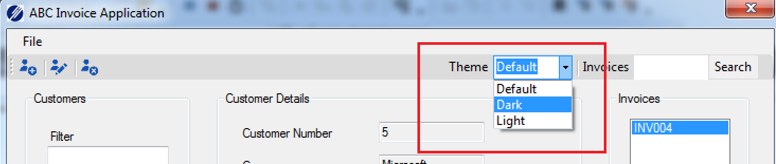

Figure 4.8.1 Theme Selection

Figures 4.8.2 shows the look and feel of each of the three themes.

|  |  |  |
| --- | --- | --- |
|  |  |  |

Figure 4.8.2 Theme Look and Feel (default, dark and light)

# Testing

The following test table describes the details and steps of several tests that can be used for checking the functionality of the ABC Invoice application.

In the case of a failed test, comments are to be provided in the Pass/Fail column.

## Login Test

|  |  |  |  |
| --- | --- | --- | --- |
| **Title:** | Login | | |
| **Description:** | Tests authentication of username and password | | |
|  | | | |
| **ID** | **Instructions** | **Expected** | **Pass/Fail** |
| 1.0 | Open application.  Type ‘MyFitness’ in username.  Type ‘pass’ in password.  Click ‘Login’ button. | Login form disappears  Main form is displayed | Pass |
| 1.1 | Click’ File’ then ‘Exit’.  Open the application.  Type ‘abc’ in username.  Type ‘abc’ in password.  Click ‘Login’ button. | Error message ‘Invalid username or password’ will be displayed | Pass |
| 1.2 | Click red X close button | Application closes | Pass |
| 1.3 | Open application.  Login as per Test 1.0  Click File menu item then ‘Exit’ | Application closes | Pass |

## View Customer Test

|  |  |  |  |
| --- | --- | --- | --- |
| **Title:** | View Customers | | |
| **Description:** | Tests that customer details are displayed correctly | | |
|  | | | |
| **ID** | **Instructions** | **Expected** | **Pass/Fail** |
| 2.0 | Login (as per Test 1.0) | Main form is displayed.  Customer name ‘Albert’ is selected.  Customer details for ‘Albert’ are displayed:  Customer number (5), company (Microsoft), first name (Albert), last name (Smith), street address (123 Main), suburb (Dianella), state (WA), post code (6000), contact phone (123444). | Pass |
| 2.1 | Click on a different customer name in the customer list | The customer name clicked on is selected.  Customer details for the selected customer are displayed in the Customer details section. | Pass |
| 2.2 | Click’ File’ then ‘Exit’. | Application closes. | Pass |

## View Invoices Test

|  |  |  |  |
| --- | --- | --- | --- |
| **Title:** | View Invoices | | |
| **Description:** | Tests that invoice details are displayed correctly | | |
|  | | | |
| **ID** | **Instructions** | **Expected** | **Pass/Fail** |
| 3.0 | Login (as per Test 1.0) | Main form is displayed.  Customer name ‘Albert’ is selected.  Customer details for ‘Albert’ are displayed:  Customer number (5), company (Microsoft), first name (Albert), last name (Smith), street address (123 Main), suburb (Dianella), state (WA), post code (6000), contact phone (123444).  Invoice number ‘INV005’ is selected.  Invoice Details section contains the following items   |  |  |  |  |  |  | | --- | --- | --- | --- | --- | --- | | Item Num | Item | Description | Cost | Qty | Total Cost | | 1 | Mouse | Wireless Mouse | 14.99 | 2 | 29.98 | | 2 | Macbook Pro | I7 8Gb RAM 15-inch | 1450.00 | 2 | 2900.00 | | 3 | Monitor | DELL 16:9 24inch | 350.00 | 1 | 350.00 |   Payment Status shows ‘Unpaid. Payment due on <today’s date> dd/MM/yyyy’  Total Invoice Cost shows ‘$3279.98’ | Pass |
| 3.1 | Click on a customer name ‘Dave’ | Customer name ‘Dave’ is selected.  Customer details for ‘Dave’ are displayed:  Customer number (1), company (Intekka), first name (Dave), last name (Pyle), street address (349 Grand Prom), suburb (Dianella), state (WA), post code (6059), contact phone (0478220117). | Pass |
| 3.2 | Click on invoice number ‘INV001’ | Invoice number ‘INV001’ is selected.  Invoice Details section contains the following items   |  |  |  |  |  |  | | --- | --- | --- | --- | --- | --- | | Item Num | Item | Description | Cost | Qty | Total Cost | | 1 | Mouse | Wireless Mouse | 14.99 | 2 | 29.98 | | 2 | Macbook Pro | I7 8Gb RAM 15-inch | 1450.00 | 2 | 2900.00 |   Payment Status shows ‘Unpaid. Payment due on <today’s date> dd/MM/yyyy’  Total Invoice Cost shows ‘$2979.98’ | Pass |
| 3.3 | Click’ File’ then ‘Exit’. | Application closes. | Pass |

## Add Customer Test

|  |  |  |  |
| --- | --- | --- | --- |
| **Title:** | Add Customer | | |
| **Description:** | Tests that a new customer can be added | | |
|  | | | |
| **ID** | **Instructions** | **Expected** | **Pass/Fail** |
| 4.0 | Login (as per Test 1.0)  Click on ‘Add Customer’ button | The Customer form will be displayed.  Customer Number field is read only and contains a ‘8’.  All other fields are empty. | Pass |
| 4.1 | Type ‘ABC’ in company field.  Type ‘Fred’ in first name field.  Type ‘Bloggs’ in last name field.  Type ‘333 Smith St’ in street address field.  Type ‘Perth’ in suburb field.  Select ‘WA’ from state drop down list.  Type ‘6000’ in postcode field.  Click the ‘Save’ button | An error symbol will be displayed next to the ‘Contact Phone’ field. | Pass |
| 4.2 | Type ‘12345678’ into the contact phone field.  Click the ‘Save’ button | The Customer form will disappear.  The new customer’s name will be added and selected in the customer list.  The customer details will appear in the Customer Details section. | Pass |

## Add Invoice Test

|  |  |  |  |
| --- | --- | --- | --- |
| **Title:** | Add Invoice | | |
| **Description:** | Tests that a new invoice can be added | | |
|  | | | |
| **ID** | **Instructions** | **Expected** | **Pass/Fail** |
| 5.0 | Click on a customer name ‘Fred’ | Customer name ‘Fred’ is selected.  Customer details for ‘Fred’ are displayed:  Customer number (8), company (ABC), first name (Fred), last name (Bloggs), street address (333 Smith St), suburb (Perth), state (WA), post code (6000), contact phone (12345678). | Pass |
| 5.1 | Click on ‘Add Invoice’ button | The ‘Add Invoice’ form will be displayed.  ‘Invoice Number’ field is read only and contains an invoice number ‘INV008’.  Payment Due Date is set to today’s date.  Payment Status checkbox is unchecked.  No items are listed.  The ‘Save’ button is disabled. | Pass |
| 5.2 | Check the ‘Paid’ checkbox next to ‘Payment Status’.  Set payment date to yesterday’s date.  Select ‘Monitor’ from the Item drop-down list.  Change the quantity to 2. | A tick will be displayed inside the ‘Paid’ checkbox.  The Date Paid lable and Date Paid date picker will show. Date Paid date picker is set to yesterday’s date.  The Item’s table will show:   |  |  |  |  |  | | --- | --- | --- | --- | --- | | Item | Description | Cost | Qty | Total Cost | | Monitor | DELL 16:9 24inch | 350.00 | 2 | 700 |   Invoice Total field shows ‘$700.00’  The ‘Save’ button is enabled. | Pass |
| 5.3 | Click the ‘Save’ button | The ‘Add Invoice’ form disappears.  The main form is displayed.  Customer name ‘Fred’ is selected in the customer list.  The invoice number ‘INV008’ is selected in the invoices list.  Invoice Details section contains the following items:   |  |  |  |  |  |  | | --- | --- | --- | --- | --- | --- | | Item Num | Item | Description | Cost | Qty | Total Cost | | 3 | Monitor | DELL 16:9 24inch | 350.00 | 2 | 700 |   Payment Status shows ‘Paid on <yesterday’s date>  Total Invoice Cost shows ‘$700.00’ | Pass |

## Edit Invoice Test

|  |  |  |  |
| --- | --- | --- | --- |
| **Title:** | Edit Invoice | | |
| **Description:** | Tests that an invoice can be edited | | |
|  | | | |
| **ID** | **Instructions** | **Expected** | **Pass/Fail** |
| 6.0 | Click on a customer name ‘Dave.  Click on invoice number ‘INV002’ | Customer name ‘Dave is selected.  Customer details for ‘Dave’ are displayed:  Customer number (1), company (Intekka), first name (Dave), last name (Pyle), street address (349 Grand Prom), suburb (Dianella), state (WA), post code (6059), contact phone (0478220117).  Invoice number ‘INV002’ is selected.  Invoice Details section contains the following items:   |  |  |  |  |  |  | | --- | --- | --- | --- | --- | --- | | Item Num | Item | Description | Cost | Qty | Total Cost | | 3 | Monitor | DELL 16:9 24inch | 350.00 | 1 | 350.00 | | 4 | Dock | USB HDMI DVI Dual Monitor | 200.00 | 2 | 400.00 |   Payment Status shows ‘Unpaid. Payment due on <today’s date> dd/MM/yyyy’  Total Invoice Cost shows ‘$750.00’ | Pass |
| 6.1 | Click on ‘Edit Invoice’ button | The ‘Edit Invoice’ form will be displayed.  ‘Invoice Number’ field is read only and contains ‘INV002’.  Payment Due Date is set to today’s date.  Payment Status checkbox is unchecked.  Item’s table shows:   |  |  |  |  |  | | --- | --- | --- | --- | --- | | Item | Description | Cost | Qty | Total Cost | | Monitor | DELL 16:9 24inch | 350.00 | 1 | 350.00 | | Dock | USB HDMI DVI Dual Monitor | 200.00 | 2 | 400.00 |   Invoice Total shows ‘$750.00’ | Pass |
| 6.2 | Change the Payment Due Date to yesterday’s date.  Change the quantity to 2 for the Monitor item.  Click ‘Dock’ and select ‘USB Drive’ from the list. | Payment Due Date shows yesterday’s date.  Item’s table shows:   |  |  |  |  |  | | --- | --- | --- | --- | --- | | Item | Description | Cost | Qty | Total Cost | | Monitor | DELL 16:9 24inch | 350.00 | 2 | 700 | | Dock | USB HDMI DVI Dual Monitor | 200.00 | 2 | 400.00 |   Invoice Total shows ‘$1100.00’ | Pass |
| 6.3 | Click the ‘Save’ button | The ‘Edit Invoice’ form disappears.  The main form is displayed.  Customer name ‘Dave is selected in the customer list.  Invoice number ‘INV002’ is selected in the invoices list.  Invoice Details section contains the following items:   |  |  |  |  |  |  | | --- | --- | --- | --- | --- | --- | | Item Num | Item | Description | Cost | Qty | Total Cost | | 3 | Monitor | DELL 16:9 24inch | 350.00 | 2 | 700.00 | | 4 | Dock | USB HDMI DVI Dual Monitor | 200.00 | 2 | 400.00 |   Payment Status shows ‘Overdue. Payment was due on <yesterday’s date>’  Total Invoice Cost shows ‘$1100.00’ | Pass |

## Delete Invoice Test

|  |  |  |  |
| --- | --- | --- | --- |
| **Title:** | Delete Invoice | | |
| **Description:** | Tests that an invoice can be deleted | | |
|  | | | |
| **ID** | **Instructions** | **Expected** | **Pass/Fail** |
| 7.0 | Click on a customer name ‘Dave.  Click on invoice number ‘INV002’ | Customer name ‘Dave is selected.  Customer number, company, first name, last name, street address, suburb, state, post code, contact phone for ‘Dave are displayed in the Customer Details section.  Invoice number ‘INV002’ is selected.  Invoice Details section contains the following items:   |  |  |  |  |  |  | | --- | --- | --- | --- | --- | --- | | Item Num | Item | Description | Cost | Qty | Total Cost | | 3 | Monitor | DELL 16:9 24inch | 350.00 | 2 | 700.00 | | 4 | Dock | USB HDMI DVI Dual Monitor | 200.00 | 2 | 400.00 |   Payment Status shows ‘Overdue. Payment was due on <yesterday’s date>’  Total Invoice Cost shows ‘$1100.00’ | Pass |
| 7.1 | Click on ‘Delete Invoice’ button | A message dialog is displayed showing’ Are you sure you want to delete invoice: INV002? |  |
| 7.2 | Click ‘Yes’ | The message dialog disappears.  The main form loads.  Customer name ‘Dave is selected in the customer list.  Invoice number ‘INV001’ is selected in the invoice list.  Invoice number ‘INV002’ no longer appears in the invoice list.  Invoice Details section contains the following items:   |  |  |  |  |  |  | | --- | --- | --- | --- | --- | --- | | Item Num | Item | Description | Cost | Qty | Total Cost | | 1 | Mouse | Wireless Mouse | 14.99 | 2 | 29.98 | | 2 | Macbook Pro | i7 8Gb RAM 15-inch | 1450.00 | 2 | 2900.00 |   Payment Status shows ‘Unpaid. Payment due on <today’s date>  Total Invoice Cost shows ‘$2929.98’ | Pass |

## Edit Customer Test

|  |  |  |  |
| --- | --- | --- | --- |
| **Title:** | Edit Customer | | |
| **Description:** | Tests that a customer can be edited | | |
|  | | | |
| **ID** | **Instructions** | **Expected** | **Pass/Fail** |
| 8.0 | Click on a customer name ‘Albert. | Customer name ‘Albert’ is selected.  Customer details for ‘Albert’ are displayed:  Customer number (5), company (Microsoft), first name (Albert), last name (Smith), street address (123 Main), suburb (Dianella), state (WA), post code (6000), contact phone (123444). | Pass |
| 8.1 | Click on ‘Edit Customer’ button  Delete ‘Smith’ from last name field.  Type ‘Brown’ in last name field. | The ‘Customer’ form will be displayed.  ‘Customer Number’ field is read only and contains ‘5’.  Last name contains ‘Brown’ | Pass |
| 8.2 | Click the ‘Save’ button | The ‘Customer’ form disappears.  The main form is displayed.  Customer name ‘Albert’ is selected in the customer list.  Last Name now displays ‘Brown’. | Pass |

## Delete Customer Test

|  |  |  |  |
| --- | --- | --- | --- |
| **Title:** | Delete Customer | | |
| **Description:** | Tests that a customer can be deleted | | |
|  | | | |
| **ID** | **Instructions** | **Expected** | **Pass/Fail** |
| 9.0 | Click on a customer name ‘Dave. | Customer name ‘Dave’ is selected.  Customer number (1), company (Intekka), first name (Dave), last name (Pyle), street address (349 Grand Prom), suburb (Dianella), state (WA), post code (6059), contact phone (0478220117).  Invoice number ‘INV002’ is selected. | Pass |
| 9.1 | Click on ‘Delete Customer’ button | A message dialog is displayed showing’ Are you sure you want to delete customer Dave? | Pass |
| 9.2 | Click ‘Yes’ | The message dialog disappears.  The main form loads.  Customer name ‘Dave’ no longer appears in the customer list.  Customer name ‘Albert’ is selected.  Customer number, company, first name, last name, street address, suburb, state, post code, contact phone for ‘Albert’ are displayed in the Customer Details section. | Pass |

## Search Customers Test

|  |  |  |  |
| --- | --- | --- | --- |
| **Title:** | Search by Customer Name | | |
| **Description:** | Tests that a search can be performed on customers by customer name | | |
|  | | | |
| **ID** | **Instructions** | **Expected** | **Pass/Fail** |
| 10.0 | Type ‘A’ into the ‘Filter’ field. | All customers apart from those whose names begin with ‘A’ are removed from the customer list.  Customer list shows: Albert, Alex, Andrew, Andy.  Customer name ‘Albert’ is selected.  Customer number, company, first name, last name, street address, suburb, state, post code, contact phone for ‘Albert’ are displayed in the Customer Details section. | Pass |
| 9.1 | Type ‘Al’ into the ‘Filter’ field. | All customers apart from those whose names begin with ‘Al’ are removed from the customer list.  Customer list shows: Albert, Alex  Customer name ‘Albert’ is selected.  Customer number, company, first name, last name, street address, suburb, state, post code, contact phone for ‘Albert’ are displayed in the Customer Details section. | Pass |

## Search Invoices Test

|  |  |  |  |
| --- | --- | --- | --- |
| **Title:** | Search by Invoice Number | | |
| **Description:** | Tests that a search can be performed for invoices by invoice number | | |
|  | | | |
| **ID** | **Instructions** | **Expected** | **Pass/Fail** |
| 10.0 | Type ‘I’ into the ‘Invoices’ search field. | A pop-up list will appear under the ‘Invoices’ search field showing: INV003, INV004, INV005, INV006, INV007, INV008 | Pass |
| 10.1 | Click on ‘INV003’ in the pop-up list | The ‘Invoices’ search field shows ‘INV003’ | Pass |
| 10.2 | Click the ‘Search’ button | The ‘Invoices’ search field is empty.  ‘Lena’ is selected in the customer list.  Customer number, company, first name, last name, street address, suburb, state, post code, contact phone for ‘Lena’ are displayed in the Customer Details section.  Invoice number ‘INV003’ is selected.  Invoice Details section contains the following items:   |  |  |  |  |  |  | | --- | --- | --- | --- | --- | --- | | Item Num | Item | Description | Cost | Qty | Total Cost | | 5 | Keyboard | Wireless Keyboard | 34.99 | 3 | 104.97 | | 6 | USB Drive | SanDisk 16Gb | 59.00 | 4 | 236.00 |   Payment Status shows ‘Unpaid. Payment due on <today’s date>’  Total Invoice Cost shows ‘$340.97’ | Pass |
| 10.3 | Type ‘xx’ into the ‘Invoices’ search field.  Click the ‘Search’ button | A message dialog is displayed showing ’No results for invoice number: XX’ | Pass |
| 10.4 | Click ‘OK’ | The message dialog box disappears. | Pass |

## Change Interface Background Test

|  |  |  |  |
| --- | --- | --- | --- |
| **Title:** | Change Theme | | |
| **Description:** | Tests that the interface background image can be changed | | |
|  | | | |
| **ID** | **Instructions** | **Expected** | **Pass/Fail** |
| 10.0 | Select ‘Dark’ from the ‘Theme’ drop down list | Theme field shows ‘Dark’  The background interface of the main form changes to a dark image. | Pass |
| 10.1 | Click the ‘Add Customer’ button | The ‘Customer’ form appears with the same dark background image as the main form. | Pass |
|  | Click the ‘Cancel’ button | The ‘Customer’ form disappears. | Pass |
| 10.1 | Select ‘Light’ from the ‘Theme’ drop down list | Theme field shows ‘Dark’  The background interface of the main form changes to a light image. | Pass |
| 10.2 | Select ‘Default’ from the ‘Theme’ drop down list | Theme field shows ‘Default’  The background interface of the main form changes back to the default background (grey). | Pass |
| 10.3 | Click’ File’ then ‘Exit’. | Application closes. | Pass |

Error tests

# Annex A – UI Component Details

The tables below detail each component of the UI and a description on the function of the component.

## Login Form UI Components

|  |  |  |
| --- | --- | --- |
| **Component** | **Name** | **Description** |
| Label | lblTitle | Displays ‘ABC Invoice Application’ |
| Group Box | gBoxLogin | Displays ‘Login Details’ group box |
| Label | lblUsername | Displays ‘Username’ |
| Text Box | txtBoxUser | Accepts Username |
| Label | lblPassword | Displays ‘Password’ |
| Text Box | txtBoxPassword | Accepts Password |
| Button | btnLogin | ‘Login’ button |
| Label | lblLoginError | Displays ‘Invalid username or password’ |

## Main Form UI Components

|  |  |  |
| --- | --- | --- |
| **Component** | **Name** | **Description** |
| Menu Strip | msFile | Main menu strip |
| Menu Item | fileToolStripMenuItem | ‘File’ menu item |
| Menu Item | customerToolStripMenuItem | ‘Customer’ menu item |
| Menu Item | addCustomerToolStripMenuItem | ‘Add Customer’ menu item |
| Menu Item | editCustomerToolStripMenuItem | ‘Edit Customer’ menu item |
| Menu Item | deleteCustomerToolStripMenuItem | ‘Delete Customer’ menu item |
| Menu Item | exitToolStripMenuItem | ‘Exit’ menu item |
| Tool Strip | tsMain | Main tool strip |
| Button | btnAddCust | ‘Add Customer’ button |
| Button | btnEditCust | ‘Edit Customer’ button |
| Button | btnDeleteCust | ‘Delete Customer’ button |
| Text Box | tslblTheme | Displays ‘Theme’ |
| Check Box | cboxTheme | Displays/Accepts theme name |
| Label | tsLblInvoices | Displays ‘Invoices’ |
| Text Box | txtBoxInvSearch | Displays/Accepts invoice number search |
| Separator | toolStripSeparator1 | Tool strip separator |
| Separator | toolStripSeparator2 | Tool strip separator |
| Separator | toolStripSeparator3 | Tool strip separator |
| Text Box | gBoxCustomers | Displays ‘Customers’ |
| Label | lblFilter | Displays ‘Filter’ |
| Label | tbSearchCust | Displays/Accepts customer name search |
| Label | lbCustomers | Displays list of customer first names |
| Group Box | gBoxCustomerDetails | Displays ‘Customer Details’ |
| Label | lblCustNum | Displays ‘Customer Number’ |
| Label | lblCompany | Displays ‘Company’ |
| Label | lblFirstName | Displays ‘First Name’ |
| Label | lblLastName | Displays ‘Last Name’ |
| Label | lblStreet | Displays ‘Street Address’ |
| Label | lblSuburb | Displays ‘Suburb’ |
| Label | lblState | Displays ‘State’ |
| Label | lblPostCode | Displays ‘Post Code’ |
| Label | lblPhone | Displays ‘Contact Phone’ |
| Text Box | txtBoxCustNum | Displays customer number |
| Text Box | txtBoxCompany | Displays/Accepts company |
| Text Box | txtBoxFirstName | Displays/Accepts first name |
| Text Box | txtBoxLastName | Displays/Accepts last name |
| Text Box | txtBoxStreet | Displays/Accepts street address |
| Text Box | txtBoxSuburb | Displays/Accepts suburb |
| Text Box | txtBoxState | Displays/Accepts state |
| Text Box | txtBoxPostCode | Displays/Accepts post code |
| Text Box | txtBoxPhone | Displays/Accepts contact phone |
| Group Box | gBoxInvoices | Displays ‘Invoices’ |
| Label | lbInvoiceNum | Displays a list of invoice numbers |
| Button | btnAddInvoice | ‘Add Invoice’ button |
| Button | btnEditInvoice | ‘Edit Invoice’ button |
| Button | btnDeleteInvoice | ‘Delete Invoice’ button |
| Group Box | gbInvoiceDetails | Displays ‘Invoice Details’ |
| DataGridView | dgInvoiceDetails | Invoice details datagridview |
| Label | lblPaymentStatus | Displays ‘Payment Status’ |
| Label | lblStatus | Displays payment status |
| Label | lblTotalInvoiceCost | Displays ‘Total Invoice Cost’ |
| Text Box | tbTotalInvoiceCost | Displays total invoice cost |

## Add Customer, Edit Customer UI Components

|  |  |  |
| --- | --- | --- |
| **Component** | **Name** | **Description** |
| Group Box | gBoxCustFormDetails | Displays ‘Customer Details’ |
| Label | lblCustNumber | Displays ‘Customer Number’ |
| Label | lblCompany | Displays ‘Company’ |
| Label | lblFirstName | Displays ‘First Name’ |
| Label | lblLastName | Displays ‘Last Name’ |
| Label | lblStreet | Displays ‘Street Address’ |
| Label | lblSuburb | Displays ‘Suburb’ |
| Label | lblState | Displays ‘State’ |
| Label | lblPostCode | Displays ‘Post Code’ |
| Label | lblPhone | Displays ‘Contact Phone’ |
| Text Box | txtBoxCustNum | Displays customer number |
| Text Box | txtBoxCompany | Displays/Accepts company |
| Text Box | txtBoxFirstName | Displays/Accepts first name |
| Text Box | txtBoxLastName | Displays/Accepts last name |
| Text Box | txtBoxStreet | Displays/Accepts street address |
| Text Box | txtBoxSuburb | Displays/Accepts suburb |
| Combo Box | cboxState | Displays/Accepts state |
| Text Box | txtBoxPostCode | Displays/Accepts post code |
| Text Box | txtBoxPhone | Displays/Accepts contact phone |
| Label | lblAllReqd | Displays ‘* all fields required’ |
| Button | btnCustSave | ‘Save’ button |
| Button | btnCancel | ‘Cancel’ button |

## Add Invoice, Edit Invoice UI Components

|  |  |  |
| --- | --- | --- |
| **Component** | **Name** | **Description** |
| Group Box | gbInvoice | Displays ‘Invoice Details’ |
| Label | lblInvoiceNum | Displays ‘Invoice Number’ |
| Label | lblPayDue | Displays ‘Payment Due Date |
| Label | lblDatePaid | Displays ‘Date Paid’ |
| Date Picker | paymentDatePicker | Displays/Accepts payment date |
| Label | lblPayStatus | Displays ‘Payment Status’ |
| DataGridView | dgAddInvoiceItems | Invoice Item datagridview |
| Label | lblInvoiceTotal | Displays ‘Invoice Total’ |
| Text Box | tbInvoiceNum | Displays invoice number |
| Date Picker | paymentDueDatePicker | Displays/Accepts payment due date |
| Check Box | cboxPaidStatus | Displays/Accepts payment status |
| Text Box | txtBoxInvoiceTotal | Displays invoice total |
| Button | btnSave | ‘Save’ button |
| Button | btnCancel | ‘Cancel’ button |

**7. Database Design and screenshots**